Original image: size(f)= 900x600x3; class= uint8

   

1. g = f(:, :, :) (b) g = f(:, :, 1) (c) g = f(:, :, 2) (d) g = f(:, :, 3)

Flipping image vertically

fp=f(end:-1:1, : ); % flipping original 3D image

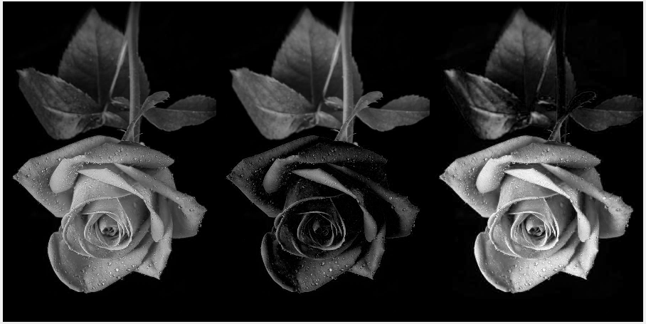

**fp=f(end:-1:1,end:-1:1);**



g = f(:, :, 1) ;

gp=g(end:-1:1, : );

imshow(gp)



Cropped image

 

1. fc = f(100:600, 100:600); (b) gc = g(100:600, 100:600);

Sampling image

 

1. fs = f(1:5:end, 1:5:end) (b) gs=g(1:5:end, 1:5:end)

plot(g(450, :))

